Course Description:

My focus in ELA 10 is to give you the foundation that you need to develop the reading and writing skills required for academic English at the high school level. This year you will be asked to write (A LOT!) and to learn the process of writing. You will be required to show your mastery of terms learned in grades 7, 8 and 9 so that you don’t have to worry about these in grades 11 and 12. You will be asked to read (A LOT!) and not just in class. And perhaps most uncomfortably, you will be asked to THINK. You will be asked to think about the world, our relationships with others and about yourself. This will not be easy and requires a thoughtful and reflective mind and attitude. This takes time to develop.

English 10-1 is the first of the high school English courses designed for students planning to attend a post secondary institution. English 10-1, 20-1 and 30-1 are geared towards helping students whose careers will involve the development, production, teaching and study of more complex texts. It is a rigorous course which focuses on listening and speaking, reading and writing and viewing and representing all with an emphasis on language development and critical thinking and learning through language and literature.

Units of Study

The following will give you an approximate idea of our units of study and the dates that we will be studying them. At the beginning of each unit, you will receive a more detailed outline of the expectations of that unit.
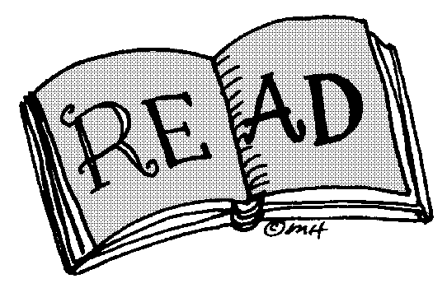
- Short Stories Feb. 2 – Feb. 27th
- Novel To Kill a Mockingbird March 4 – April 5
- Poetry April 8 – April 18
- Shakespeare Romeo and Juliet April 22 – May 24
- Film Study May 27 – June 6th
- Writing unit Feb. 4 – June 18th

Assessment: Your final marks will be based on the following:

Term Mark (in class work) 70%

Text Comprehension 25%

- reading comprehension exams, questions on literature, reading quizzes, notes on literature, vocabulary and spelling quizzes, literary terms quizzes.

Text Creation 30%

- Critical essays and responses, personal responses, newspaper articles, journal entries, short stories.

Representation 10%

- Visuals and multimedia representations

Collaboration 5%

- Visual and multimedia presentations, oral presentations, group discussion or group work marks, project work, pre reading research assignments, class discussion marks.

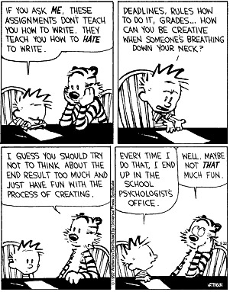

Final Exam 30%

Written 15%
Reading Comprehension 15%

PART A FINAL EXAM:
Tuesday JUNE 16TH 8:45-10:45

Expectations for the Successful Student

- Respect – Show respect and you will receive respect. Respect your teacher, your peers, your classroom, your school and yourself!

- Regular Attendance Is Mandatory – There is a direct correlation between attending class and achieving good results in school. Each attendance problem is unique and requires individual attention. When you miss a class YOU are responsible for getting missed work and YOU are responsible for catching up. If you miss an hour of class, you should assume you have an hour of homework. Should you choose to inexcusably miss class you will immediately be given a noon hour detention. As well, lates are a distraction to learning. EVERY late will result in a noon hour detention. Class begins when the second bell rings.

- Be attentive and take notes during lectures and class discussions. Have an intellectual curiosity. Do your homework to the best of your ability and use time-management to complete all your assignments. Avoid zeros. This will allow for success in this class and in your pursuit of life lone learning

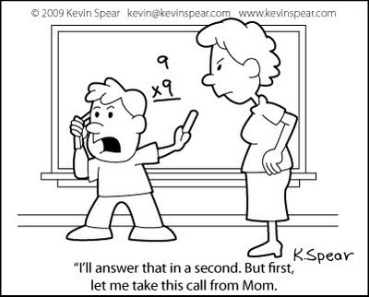
- Plagiarism – Plagiarism (den.) – To steal or pass off the ideas or words of another as one’s own; to use another’s production without crediting the source is to commit literary theft; to present as new and original an idea or product derived from an existing source. (Merriam-Webster’s Collegiate Dictionary, 10th edition) Plagiarism is a serious offence. When doing research or preparing to write an essay or doing any other written work all students are expected to collect information, synthesize and understand it and then re-write it into their own words. Any information taken directly from a book or magazine, the internet or any other published or copy written work must be appropriately referenced. Any work found to be plagiarized in whole or in part will be given a grade of zero and that student’s or those students’ name(s) will be forwarded to the vice-principal.

- No Hats / No Cell phones – Cell phones and IPODs/ MP3 players are not allowed in the school between 8:30am and 3:30 pm. IF you are caught with your own device, it will be sent to Mr. Pilipchuk’s office and your parents will have to come and pick it up. NO exceptions. Cell phone use distracts from the learning that needs to occur in class. School devices will be provided when students need access to the internet.

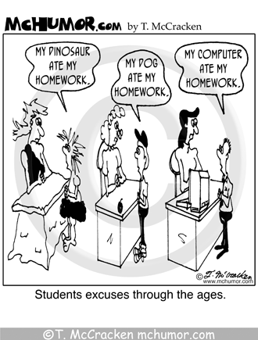
- Late Assignment Policy – Students are expected to hand in ALL Assignments. If an assignment is not handed in parents will be called immediately. A zero will be assigned if the assignment is not turned in before the assignments are marked and handed back.

- Missed Exam Policy – Unless other arrangements are made previously, all missed exams will be written the day the student returns to class.

Course Goals:
Students will be able to…
- Continue developing familiarity with the elements of fiction, focusing on the creation of effective theme statements and the role of characterization.
- Effectively use the plot diagram to create plot sequence and its role in theme and characterization; identify plot manipulations and their purpose with assistance from the teacher
- Identify with confidence first and third person point of view. Use with some assistance the omniscient and limited omniscient points of view; understand how point of view helps to develop the theme
- Identify character motivation; understand how the characters within the plot line behave within a social setting, see themselves within their society, and the degree to which they are influenced by other characters.
- Discuss theme and its relationship to other literary terms, especially characterization, setting and conflict resolution.
- Understand that an essay consists of an introduction containing a specific thesis statement which directs the essay, body paragraphs which develop a controlling idea using clear literary examples and a specific conclusion that links all elements of the essay.
- Be introduced to the concept of substantiation-proof, facts, explanations, examples, opinions. Students will be expected to prove all statements they make in both written and verbal communications.
- Know and use with confidence the following terms: theme, character types, types of conflict, sub-conflict, dialogue, soliloquy, symbolism, types of irony, sarcasm/satire, genres of literature, setting, audience, suspense, tone, mood, imagery, oxymoron, character foil, dilemma, cliché, allusion
- Be introduced to the following terms: Style, subplots, archetypes, paradox, apostrophe, allusion, allegory.
- Have knowledge of and use the various types of sentences and understand the importance of varying sentence structure, having syntactical mastery of grammar and spelling.
- Demonstrate the use of a dictionary and thesaurus to enhance reading comprehension and writing specificity.
- Write at least one essay with prior preparation of the topic, either individually or in a small group.
- Write one essay without prior knowledge of the topic.
- Be familiar with the use of figurative language. Start using figurative language within the student’s own work.
- Write and analyze poetry, focusing on the use of imagery, style, basic types, rhyme, flow. Be introduced to the rhythm of poetry through the analyses of odes, limericks and sonnets.
- Become media literate, and develop an awareness of the effectiveness of various media texts such as advertisements, songs, video, and websites.
- Be introduced to the elements of film analysis including color, sound/music, special effects, camera angles and shots, editing, props, and lighting. Be familiar with the literary traits of screenplays, short stories and novels.
- Demonstrates familiarity with all elements of a short story and apply their knowledge to written assignments.
- Begin to develop personal response writing.
- Be familiar with the proper form of literary citation and will look to enhance written assignments with literary quotations.
- Learn and practice reading strategies.
- Make an oral presentation, integrating a variety of multimedia formats.
- Read, understand and paraphrase, with teacher assistance, Shakespearean text.

