Creative Arts 10/20
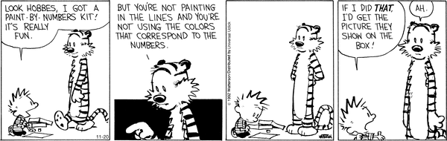
Creative Arts is a newly designed course at Caroline School. The purpose of the course is to allow students to explore various media related creative pursuits. To be successful in this course students need to be independently motivated as many students will be working on different program plans simultaneously

Units of Study
Students may choose modules that fit into four main strands of study:

- Web Design (school newspaper)
- Graphic design (art on the computer)
- Photography (photo journalism, color manipulation, aspects of photography etc.)
- Film Creation (story boarding, film editing, animation, green screen etc.)

During the first week of class students will choose the modules the wish to work on and a program will be designed for each individual student. It is important to note that once students have selected a strand and their modules, they MAY NOT change. It is, therefore, important that students consider carefully the requirements of their particular strand.

Projects

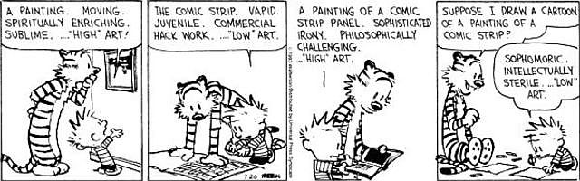
Students will have the opportunity to participate in projects as they are presented to us. These will be for extra credit.

Workshops

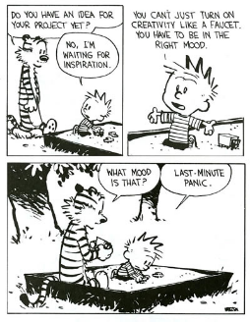
Throughout the term, we will be bringing in “experts” in the various fields that students are working on to help increase our knowledge and to start to see the application of our skills. All students are invited to participate in the workshops but they are only mandatory for those in the particular strand. We welcome suggestions for presenters!
Evaluations
Each module will have its own set of requirements. Students will be made aware of these requirements prior to accepting the module.
Classroom Expectations
- Students will work independently and with a focus to get the task done. This is essential when 30 students are working on different modules.
- Students will be responsible for setting deadlines and meeting these deadlines
- EVERYONE must be willing to both give and receive constructive criticism. This is the only way you grow as an artist.
- Regular Attendance Is Mandatory – There is a direct correlation between attending class and achieving good results in school. Students who choose to be absent from class or are late for class will be assigned a noon hour detention. If students arrive without the basic materials needed to participate in class, they will be asked to get them and then be marked late. The lunch hour detention will be served in Mr. Fuller's room the next lunch break. Chronic attendance problems will be addressed individually through the office.

Option One - School Newspaper

- When you sign up for the school newspaper, you do have some choice in the modules that you would like to choose to do. Depending on what aspects of the paper that you want to work on, you may take on different modules. Some roles include - design posters/advertisements, write articles, create short films for advertisements or interviews, publish pictures.

Grade 10 modules | Grade 11 Modules | Grade 12 modules
VISUAL COMMUNICATION COM1005 | MEDIA IMPACT COM2015
MEDIA COM1015 | ELECTRONIC LAYOUT AND PUBLISHING 2025 | ELECTRONIC LAYOUT AND PUBLISHING 3025
TYPOGRAPHY COM1025 | RASTER GRAPHICS COM2035 | RASTER GRAPHICS COM3035
GRAPHIC TOOLS COM1035 | VECTOR GRAPHICS COM 2045 | VECTOR GRAPHICS COM 3045
WEB DESIGN COM1055 | WEB DESIGN COM2055 | RICH MEDIA BASICS COM3055
AUDIO/VIDEO 1105
COM PROJECT COM1910a

Option Two - Graphic Design

When you sign up for Graphic Design, you are signing up to explore the creative and artistic side of generating computer art. You will work on several different projects that involve crafting computer generated images. You do have some choice of modules if you choose this option.

Grade 10 modules | Grade 11 Modules | Grade 12 modules
VISUAL COMMUNICATION COM1005 | MEDIA IMPACT COM2015
MEDIA COM1015 | DESIGN BRAND IDENTITY COM2155 | DESIGN ADVERTISING CAMPAIGNS COM3155
TYPOGRAPHY COM1025 | RASTER GRAPHICS COM2035 | RASTER GRAPHICS COM3035
GRAPHIC TOOLS COM1035 | VECTOR GRAPHICS COM2045 | VECTOR GRAPHICS COM3045
PRINTING COM1165 | PRINTING COM2165
COM PROJECT COM1910a | COM TECH CLIENT SERVICES 2285 | COM TECH CLIENT SERVICES 3285
 | COM PROJECT B 2910 | COM PROJECT D 3910

Option three - Film Creation

If you choose this option, you will be exploring the wonderful world of film creation. You will need to look at film techniques and you will be creating your own short films. There are fewer modules for film creation so you are forced to select the modules that are available.

Grade 10 modules | Grade 11 Modules | Grade 12 modules
VISUAL COMMUNICATION COM1005 | AV PREPRODUCTION COM2105 | AV PREPRODUCTION COM3105
MEDIA COM1015 | AV PRODUCTION COM2115 | AV PRODUCTION COM3115
AUDIO/VIDEO COM1105 | AV POSTPRODUCTION COM2125 | AV POSTPRODUCTION COM3125
ANIMATION COM1145 | ANIMATION COM2145 | ANIMATION COM3145
COM PROJECT COM1910a |  | AUDIO TECHNIQUES COM3135
 |  | AV BROADCASTING COM3165

