Visual Reflection Assignment 30-2

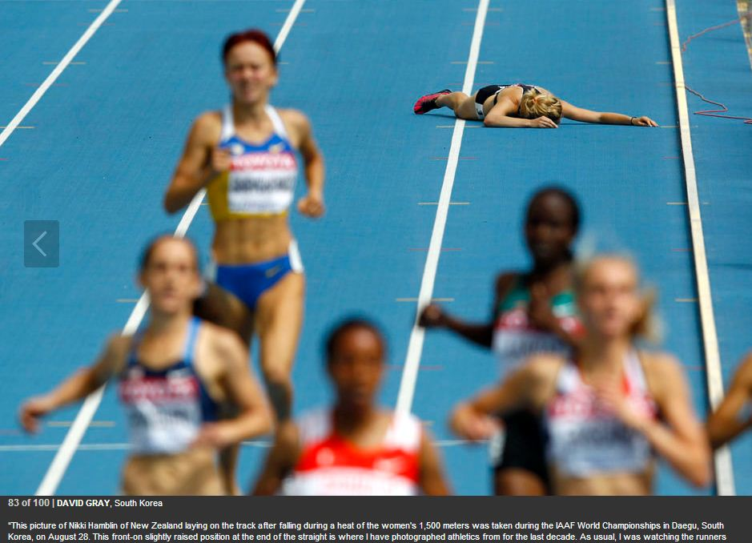
ASSIGNMENT I: VISUAL REFLECTION
Examine the photographs on the first page. Reflect upon the ideas and impressions suggested by the photographs.

The Assignment
What ideas and impressions do the photographs suggest to you? Consider the context, and develop your response by referring to the photographs.

In your writing, you may respond personally, critically, and/or creatively.
You must
• select a prose form that is appropriate to the ideas you wish to express and that will enable you to effectively communicate to the reader
• consider how you can create a strong unifying effect

