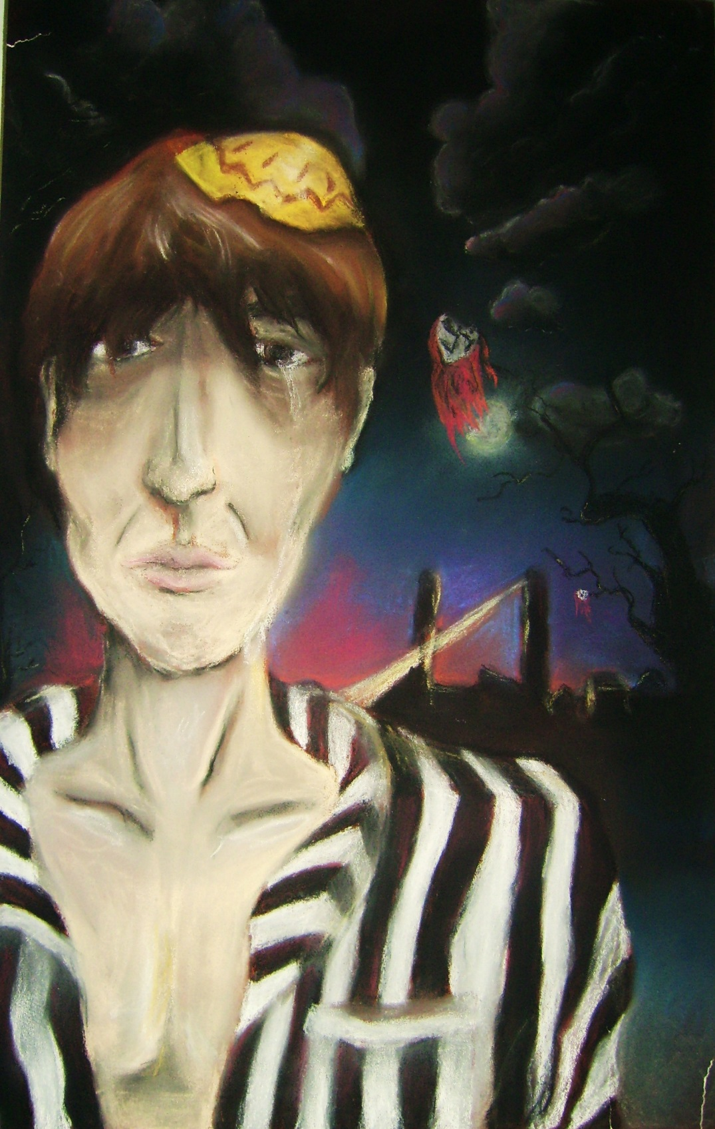
Night by Elie Wiesel
30-2 Independent Novel Study
Reading Diary Hope and Redemption Unit
Night and Film Study

Nov. 26 –Research Assignment (1 period)
Nov. 27 – Pre-reading discussion in group, silent reading and finish
research Assignment (2 periods)
Nov. 28 – Research DUE – Discussion and QUIZ on Chapter 1 (1
period)
Dec. 1 - Chapter 2/3 pg 23-34 – Questions and discussion period one –
work on graphic novel period two (2 periods)
Dec. 2 – Chapter 4 pg 35-46 Questions (1 period)
Dec. 3 – Chapter 5 47-65 Discussion and Chapter 6 pg 66-84 Questions
(2 periods)
Dec. 4 – Chapter 7 pg 84-97 Questions. (1 period)
Dec. 8 – Read “Making No become Yes” discussion and activities. (2
periods)
Dec. 9 – Found Poem assignment and matters of choice paragraph (1
period)
Dec. 10 –Found poem work (2 periods)
Dec. 11 – In class Visual Response assignment (1 period)
Dec. 12 –Intro to film study/view film (2 periods)
Dec. 15 – View film (1 period)
Dec. 16 - View film and discussion (2 periods)
Dec. 17– Film activities (1 period)
Dec. 18 – Critical Essay Redemption (2 periods)
Dec. 19 – Breakfast and Unit Exam – Redemption (1 period)
Pre-reading Research

Research one of the following topics and create a power point presentation. You will be marked on how thorough and accurate your research is as well as on the visuals and creative elements of your presentation. You MUST include a proper bibliography.

Groups – 1-2

Project choices

1. a time line of the persecution of Jews in Germany
2. Jewish faith and traditions.
3. what happened to the Jewish people who fled Germany during World War II
4. the concentration camp at Auschwitz.
5. the concentration camp at Buchenwald.

6. a survivor of the holocaust’s story.
7. an incident of Genocide that was not the holocaust.
8. An in-depth look at Hitler’s beliefs and philosophies and an explanation of Hitler’s “the final solution” and his plans for Germany.
9. Research Elie Wiesel’s life. Where is he now? Where did he go after the holocaust etc. Get as many pictures of him as possible.
10. Find three poems on the holocaust that inspire you. Explain why.

For interest sake, you may want to discuss this with other students so that you aren’t all researching the same aspect of the holocaust. This knowledge will become a huge benefit as you read through this non-fiction text.
Pre-Reading Activities

1. Why are people sometimes very cruel to others? What motivates cruelty?

2. In what ways can modern society try to control cruelty?

3. What trend in the contemporary world holds the greatest danger for producing the conditions and values that could lead to a new Holocaust?

4. Some people did try to help the Jews, especially in the early days of Hitler's genocide program. Why would some people perform deeds of kindness in such circumstances?

5. What would allow otherwise "nice" people close to their eyes, minds, and hearts to events of the Holocaust?

6. What would be some of the worst effects on a young survivor of a death camp?

7. Why did so few prisoners make an effort to revolt?

8. How would the existence of hope affect people in concentration camps?

9. In the period of time following the release of prisoners from death camps, the world made visible attempts to deny the scope of the atrocities. Why would that happen?

10. Why did relatively few Jewish people move away from the growing threat of violence in the early days of Hitler's program of extermination?

11. What might someone such as a doctor, trained to preserve life but working for a death camp, do to survive his experience of sending people to death?

Night – Vocabulary Assignment
The following is Vocabulary that is specific to the novel and to the Jewish faith, please take note of these as you go through the text.

A synagogue is an institution which serves for prayer and instruction, and as a community center for a Jewish congregation.

Cabbala ('Kabbalah' means 'tradition') refers to various secret, mystical doctrines and practices.

Hasidic Jews are strict observers of fundamental, traditional, orthodox Judaism.

Kaddish is a very old prayer for the dead, recited by Jewish mourners since the Middle Ages. The prayer is related to the 'Lord's Prayer.'

Passover is a joyous Jewish festival commemorating the escape of the Hebrews from slavery in Egypt. Traditionally, the festival is celebrated for eight days.

Rosh Hashanah is the Jewish New Year, a holiday prescribed in the Torah.

Yom Kippur is the day of Atonement, the holiest Jewish holiday, observed by fasting and prayer to atone for one's sins.

Besides this vocabulary which is specific to the novel, you will probably come across words as you read that you don’t know. Please make note of them with stick it notes or on the lines provided below. You will need to collect page numbers for these as well.

_______________ ________________ ________________
_______________ ________________ ________________
_______________ ________________ ________________
_______________ ________________ ________________
_______________ ________________ ________________
_______________ ________________ ________________
When you have finished the novel you should have 25-30 words on your list. Even though you may know some of the words, if they are ones that you never use or that you feel a little unsure of, mark them down.
Instead of simply looking these words up in a dictionary, you will need to create your own story using these words.

Below is an example.

- Encumbered (page 1)
- Timidity (page 1)
- Waiflike (page 1)
- Unsentimental (page 2)
- Indulgently (page 3)

Story:

“Ah! I can’t believe how big I am!” I whisper as I look in the mirror for the third time today. I feel so encumbered by the huge belly that now protrudes from my body like some alien thing. I know that this sounds terribly unsentimental for a pregnant woman to say but sometimes I am shocked by my own body. I look at the waiflike girls in the stupid magazines and I know I have no desire to be them but I long for the days when I could reach down and pick up a pencil from the floor without having to first contemplate the operation of it. I am a fairly bold person; I don’t go through life with a sense of timidity, however while pregnant I need to ask for help to carry everything and simple tasks of old can become a huge ordeal. My husband indulgently provides whatever support he can but in the end it is I who must calm down and understand….three more months to go.

This is not an easy task. You will need to find the definition of the word and then read how it is used several times in order to use it properly. We will work on this assignment throughout our reading. Don’t leave it to the last day or you will simply end up frustrated and unable to complete it.

Minor Character Page – Night (Do NOT include Elie or Chlomo –his father)
Description
Name
Moshe the Beadle | Poor, lived humbly, liked by others, physically awkward, helps Elie with his religious studies, comes back to warn Elie and others that the Germans will kill them.
Hilda | Oldest daughter – sister to Elie
Bea | Second oldest daughter – sister to Elie
Tzipora | Youngest daughter – sister to Elie
Martha | Servant who comes to beg them to hide in her village
Madame Schachter

Creating a graphic novel…
Night pages 23-34

Elie’s voyage to and arrival at Auschwitz provides a number of graphic images and events. Your assignment is to choose those that you think are most important and create a chapter in what would be a graphic novel. (In other words you are making a comic strip.)
To accomplish this assignment, perform the following steps:

- Jot down images that you think are important as you read.
- Beside each image that you’ve chosen write what would be in the scene and any dialogue that you might include
- On the following sheets draw the images and dialogue

You will be marked on

- the number of scenes that you choose (minimum 15)
- Accuracy of the scenes depicted
- Relative importance of the scenes
- Neatness, color, professionalism

For Example: After reading page 19 – 20, I drew the following. Keep in mind that this would be colored if I was going to hand it in for this assignment.

Questions – Night – pages 35-46

- Who is Bela Katz? (35)

- Who is Yechiel?(36)

- List 4 ways the prisoners are dehumanized on pages 35 and 37.

- Quote the line on page 37 where Elie indicates how his father has changed.

- What do the Kapos keep coming in to take from the Prisoners? What does Elie thank God for? (38)

- What is the only word that has real meaning in the camp? (39)

- What happens to Elie’s father when he gets up and asks the gypsy if he can use the washroom? (39)

- What is Elie’s reaction to this?

- What is inscribed over the gates to Auschwitz? (40)

- List two reasons that Elie thinks that Auschwitz is better than Birkenau? (41)

- What do prisoners have to do when passing between the two camps? (41)

- List three pieces of advice that the young Pole gives when the prisoners arrive at their block.

- What does Elie do with the soup when it arrives? Why? (42)

- Who is Stein of Antwerp? What is he most interested in finding out? (43-44) What truth does he eventually realize? (45) What can we assume happens to him?

- How does Elie’s father show that he is wiser than Elie? (44)

- What does Akiba Drummer do at nights? (45)

- Quote the line where Elie explains how he now feels about God and his faith. (45)

- What camp do they finally arrive at after their waiting in Auschwitz is done? (46)

Read the following lines of text and list what type of figure of speech they are. Some are the same figure of speech. (Choices: personification, metaphor, simile, symbol)

- We were so many dried up trees in the heart of a desert pg 37

- My soul had been invaded- and devoured- by a black flame. Pg. 37

- I thought of us as damned souls wandering through the void. pg 36

- Perhaps it was the thick smoke which poisoned the air and took one by the throat pg 37

Night Questions on pages 66-84

- What is Rosh Hashanah? (pg 66)

- Quote four examples of Elie’s loss of faith on pages 66 – 68

- Considering that at the beginning of the novel, Elie and his father were at odds over his wanting to study the cabbala, explain the importance of the line “We had never understood one another so clearly” pg 69

- What is Yom Kippur and what do the prisoners disagree about?

- Give two reasons why Elie chooses not to fast. Pg 69

- Which unit was Elie transferred to? Pg 70

- What is “selection”? pg 71

- What two friends does Elie meet up with before the selection? Pg 71

- What is Elie’s reaction when he is not chosen for selection? Pg 72

- What does Elie’s father bring him after the selection? Pg 73

- What “inheritance” does Elie’s father give after he discovers that he was chosen at the selection? (75)

- What does Elie think about his father, as the people in his unit show kindness to him? (75)

- Akiba Drummer is the very religious man that we saw praying in the opening descriptions of the concentration camp. In this section of the novel he appears defeated. Why does Elie think he was taken by the selection (77)

- On the bottom of page 76, Elie talks about a rabbi from a little town in Poland. Why does he include this story?

- In what way do the prisoners betray Akiba Drummer? (77)

- What happens to Elie’s foot? Where does he have to go? What is the end result? (78-79)

- The rumor that the Red Army was advancing was one of many rumors of rescue in the camp. What does Elie mean when he says “And often we believed them. It was an injection of morphine” (80)

- What have the Germans decided to do with the prisoners? (81)

- What is the choice that Elie and his father have to make? (82)

- What odd task do the prisoners have to perform before leaving? (84)

English 30-2 Night Questions pages 85-97

- Who is Zalman? Consider the idea of hope…if Zalman maintains his religious ideals until the end…why does he die? (85)

- How does Elie’s Father’s presence save his life? Quote the line. (86-87)

- Elie’s father saves his life again when the march stops. Explain this. (88-89)

- Who is Rabbi Eliahou? Explain in detail. What happens to him and his son? Explain in detail.(90-91)

- What does Elie pray (91)

- Where do they finally arrive on their march? (92)

- Who does Elie meet up with in the barracks? (93)

- What sound comes to Elie as he’s almost suffocated in the barracks? (94)

- What is symbolic about the crushed violin? (95)

- How does Elie save his father’s life? (95-96)

- What strange image finishes this reading? (96) Consider what the prisoners are drinking.

Night: Further Reading–Elie Wiesel

Read the excerpts from Elie Wiesel's essay, "Why I Write: Making No Become Yes." As you read, keep in mind the fact that understanding an author's purpose is frequently important when one reads nonfiction.
Excerpts from Why I Write: Making No Become Yes

Why do I write?
Perhaps in order not to go mad. Or, on the contrary, to touch the bottom of madness. Like Samuel Beckett, the survivor expresses himself "en desespoir de cause: — out of desperation.
Speaking of the solitude of the survivor, the great Yiddish and Hebrew poet and thinker Aaron Zeitlin addresses those — his father, his brother, his friends — who have died and left him: "You have abandoned me," he says to them. "You are together, without me. I am here. Alone. And I make words."
So I do, I just like him. I also say words, write words, reluctantly.
There are easier occupations, far more pleasant ones. But for the survivor, writing is not a profession, but an occupation, a duty. Camus calls it "an honor." As he puts it: "I entered literature through worship." Other writers have said they did so through anger, through love. Speaking for myself, I would say— through silence.
It was by seeking, by probing silence that I began to discover the perils and power of the word. I never intended to be a philosopher, or a theologian. The only role I sought was that of witness. I believed that, having survived by chance, I was duty-bound to give meaning to my survival, to justify each moment of my life. I knew the story had to be told. Not to transmit an experience is to betray it. This is what Jewish tradition teaches us. But how to do this? "When Israel is in exile, so is the word," says the Zohar. The word has deserted the meaning it was intended to convey — impossible to make them coincide. The displacement, the shift, is irrevocable.
This was never more true that right after the upheaval. We all knew that we could never, never say what had to be said, that we could never express in words, coherent, intelligible words, our experience of madness on an absolute scale. The walk through flaming night, the silence before and after the selection, the monotonous praying of the condemned, the Kaddish of the dying, the fear and hunger of the sick, the shame and suffering, the haunted eyes, the demented stares. I thought that I would never be able to speak of them. All words seemed inadequate, worn, foolish, lifeless, whereas I wanted them to be searing.
Where was I to discover a fresh vocabulary, a primeval language? The language of night was not human, it was primitive, almost animal — hoarse shouting, screams, muffled moaning, savage howling, the sound of beating. A brute strikes out wildly, a body falls. An officer raises his arm and a whole community walks toward a common grave. A soldier shrugs his shoulders, and a thousand families are torn apart, to be reunited only by death. This was the concentration camp language. It negated all other language and took its place. Rather than a link, it became a wall. Could it be surmounted? Could the reader be brought to the other side? I knew the answer was negative, and yet I knew that "no" had to become "yes." It was the last wish of the dead.
The fear of forgetting remains the main obsession of all those who have passed through the universe of the damned. The enemy counted on people's incredulity and forgetfulness. How could one foil this plot? And if memory grew hollow, empty of substance, what would happen to all we had accumulated along the way? Remember, said the father to his son, and the son to his friend. Gather the names, the faces, the tears. We had all taken an oath: "If, by some miracle, I emerge alive, I will devote my life to testifying on behalf of those whose shadow will fall on mine forever and ever."
That is why I write certain things rather than others — to remain faithful.
Of course, there are times of doubt for the survivor, times when one gives in to weakness, or longs for comfort. I hear a voice within me telling me to stop mourning the past. I too want to sing of love and of its magic. I too want to celebrate the sun, and the dawn that heralds the sun. I would like to shout, and shout loudly: "Listen, listen well! I too am capable of victory, do you hear? I too am open to laughter and joy! I want to stride, head high, my face unguarded, without having to point to the ashes over there on the horizon, without having to tamper with facts to hide their tragic ugliness. For a man born blind, God himself is blind, but look, I see, I am not blind." One feels like shouting this, but the shout changes to a murmur. One must make a choice; one must remain faithful. A big word, I know. Nevertheless I use it, it suits me. Having written the things I have written, I feel I can no longer afford to play with words. If I say that the writer in me wants to remain loyal, it is because it is true. This sentiment moves all survivors; they owe nothing to anyone but everything to the dead.
I owe them my roots and my memory. I am duty-bound to serve as their emissary, transmitting the history of their disappearance, even if it disturbs, even if it brings pain. Not to do so would be to betray them, and thus myself. I believe I have said it before, elsewhere. I write to understand as much as to be understood. Will I succeed one day? Wherever one starts, one reaches darkness. God? He remains the God of darkness. Man? The source of darkness. The killer's derision, their victims' tears, the onlookers' indifference, their complicity and complacency — the divine role in all that I do not understand. A million children massacred — I shall never understand.
All these children, these old people, I see them. I never stop seeing them. I belong to them.
But they, to whom do they belong?
People tend to think that a murderer weakens when facing a child. The child reawakens the killer's lost humanity. The killer can no longer kill the child before him, the child inside him.
But with us it happened differently. Our Jewish children had no effect upon the killers. Nor upon the world. Nor upon God.
Jewish children — they haunt my writings. I see them again and again. I shall always see them. Hounded, humiliated, bent like the old men who surround them as though to protect them, unable to do so. They are thirsty, the children, and there is no one to give them water. They are hungry, but there is no one to give them a crust of bread. They are afraid, and there is no one to reassure them.
They walk in the middle of the road, like vagabonds. They are on the way to the station, and they will never return. In sealed cars, without air or food, they travel toward another world. They guess where they are going, they know it, and they keep silent. Tense, thoughtful, they listen to the wind, the call of death in the distance.
I think of them, I think of their childhood. Their childhood is a small Jewish town, and this town is no more. They frighten me; they reflect an image of myself, one that I pursue and run from at the same time — the image of a Jewish adolescent who knew no fear, except the fear of God, whose faith was whole, comforting, and not marked by anxiety.
No, I do not understand. And if I write, it is to warn the reader that he will not understand either. "You will not understand, you will never understand," were the words heard everywhere during the reign of night. I can only echo them. You, who never lived under a sky of blood, will never know what it was like. Even if you read all the books ever written, even if you listen to all the testimonies ever given, you will remain on this side of the wall, you will view the agony and death of a people from afar, through the screen of a memory that is not your own…
…But where is one to begin? Whom is one to include? One meets a Hasid in all my novels. And a child. And an old man. And a beggar. And a madman. They are all part of my inner landscape. The reason why? Pursued and persecuted by the killers, I offer them shelter. The enemy wanted to create a society purged of their presence, and I have brought some of them back. The world denied them, repudiated them, so I let them live at least within the feverish dreams of my characters…
…Why do I write? To wrench those victims from oblivion. To help the dead vanquish death.

1. In his essay Wiesel says that he writes "To help the dead vanquish death."
How does Night help the dead to vanquish death?

2. Elie Wiesel also writes "Could it [the barrier of concentration camp language] be surmounted? Could the reader be brought to the other side? I knew the answer was negative, and yet I knew that 'no' had to become 'yes.' It was the last wish of the dead."

What does Wiesel mean "Making No Become Yes"?

3. "The only role I sought was that of witness. (paragraph 6) What does Wiesel mean?

4. Explain why Night is a good title for the book.

