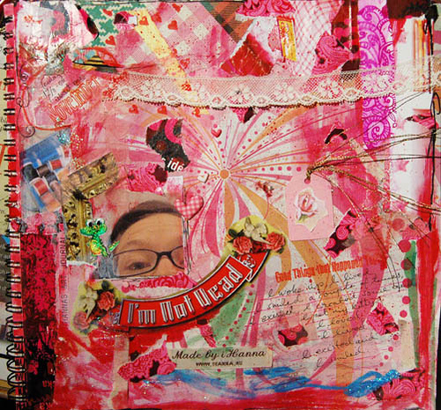
Figure 1An example of an excellent collage

This is ME - Collage Assignment

EXAMPLES OF POSSIBLE INFORMATION TO INCLUDE:

likes/dislikes
- family/friends
- Hobbies/interests

COLLAGE REMINDERS: - have a title (usually in the middle of the page)
- Fill the ENTIRE piece of paper.
- Use different sizes, colors, etc.
- If you are going to use words, do not have too many
- Need a title

Figure 2Another example with no personal pictures

