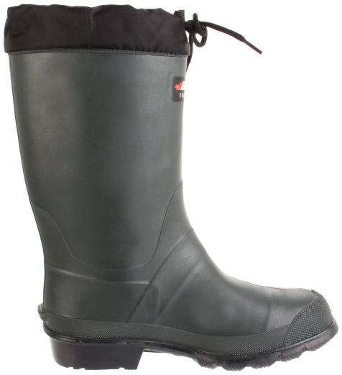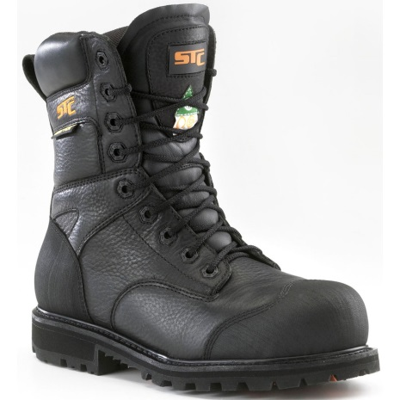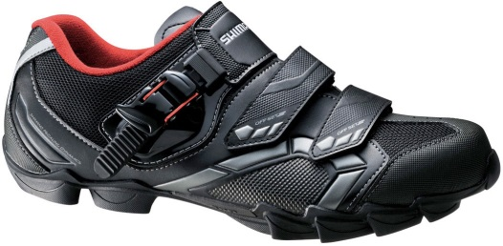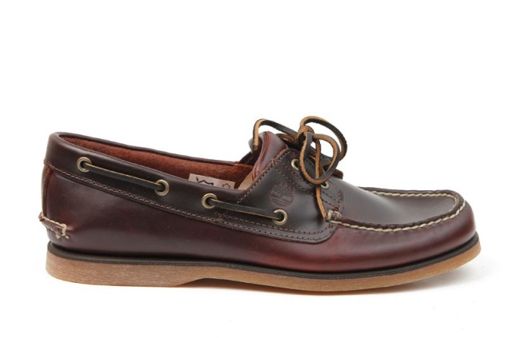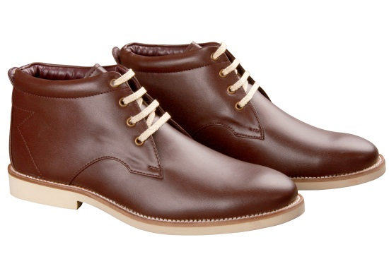

**In the novel Atticus says,  "You never really understand a person until you consider things from his point of view...until you climb into his skin and walk around in it."**

**Your writing assignment today is to try to put yourselves literally into someone else’s shoes. Above are nine different pairs of shoes; your task is to try and fill in the life of the person that wears those shoes. You can do this in the first or third person point of view and your writing should be lively and thoughtful. Fill in the blanks for me. If you have trouble getting started, begin with the following prompts…**

**“As I slip on my _______________ shoes and head out into the world I know….”**

**“He always wore his _______________ pair of shoes because….”**

**“She woke up in the morning and thought about her life….”**